Project Design Phase-II
Solution Requirements (Functional & Non-functional)

Date | 01 February 2026
Team ID | LTVIP2026TMIDS24102
Project Name | Heritage treasures: an in-depth analysis of UNESCO world heritage sites
Maximum Marks | 2 Marks

Functional Requirements:

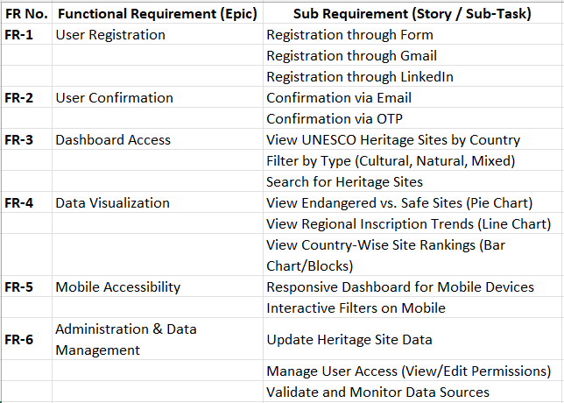
Non-functional Requirements:
